Labo 2 raspberry pi router

Raspberry pi config
Flash the OS on the raspberry pi and set static hostname and username/password.
Connect both laptop and pi to the switch.
You can connect through the host name.
Now set a static IP on the interface.
Also set a static IP on the connected PC
Install the vlan package:
sudo apt install vlan
Configure new vlan interfaces in /etc/network/interfaces.d/vlans
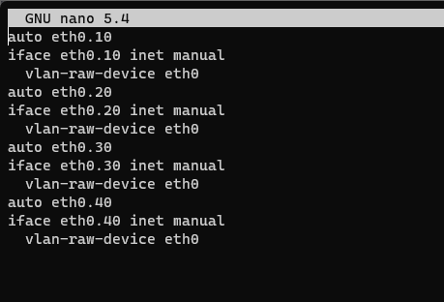
Configure the static ips of the vlans in dhcpcd.d:
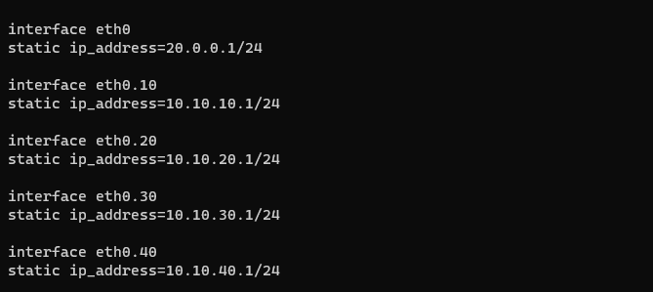

Configurating routing on pi:
Change 1 line in the /etc/sysctl.conf file:

Configuration switch:
Full configuration of the switch, creates the vlans adds the ports and setups trunks.
interface range fastEthernet 0/1
switchport mode trunk
interface range fastEthernet 0/2 – 6
switchport mode access
switchport access vlan 10
interface range fastEthernet 0/7 – 10
switchport mode access
switchport access vlan 20
interface range fastEthernet 0/11 – 14
switchport mode access
switchport access vlan 30
interface range fastEthernet 0/15 – 18
switchport mode access
switchport access vlan 40

DHCP setup on cisco switch
Ip dhcp excluced-address 10.10.10.1 -10.10.10.10
Ip dhcp excluced-address 10.10.20.1 -10.10.20.10
Ip dhcp excluced-address 10.10.30.1 -10.10.30.10
Ip dhcp excluced-address 10.10.40.1 -10.10.40.10
ip dhcp pool vlan-10
network 10.10.10.0 255.255.255.0
default-router 10.10.10.10
exit
ip dhcp pool vlan-20
network 10.10.20.0 255.255.255.0
default-router 10.10.10.20
exit
ip dhcp pool vlan-30
network 10.10.30.0 255.255.255.0
default-router 10.10.10.30
exit
ip dhcp pool vlan-40
network 10.10.40.0 255.255.255.0
default-router 10.10.10.40
exit
interface vlan 10
ip address 10.10.10.0 255.255.255.0
no shutdown
exit
interface vlan 20
ip address 10.10.20.0 255.255.255.0
no shutdown
exit
interface vlan 30
ip address 10.10.30.0 255.255.255.0
no shutdown
exit
interface vlan 40
ip address 10.10.40.0 255.255.255.0
no shutdown
exit

Ip addresses:
Raspberry pi: 20.0.0.1
Windows pc: 20.0.0.2
vlans
Name | Ip address
10 | 10.10.10.0/24
20 | 10.10.20.0/24
30 | 10.10.30.0/24
40 | 10.10.40.0/24

Sources:
Configure vlans on pi:
https://help.domotz.com/tips-tricks/configure-vlans-on-raspberry-pi/

Configure switch:
https://www.cisco.com/c/en/us/td/docs/switches/lan/catalyst2960x/software/15-2_2_e/vlan/configuration_guide/b_vlan_1522e_2960x_cg/b_vlan_152ex_2960-x_cg_chapter_0100.html

Configure raspberry pi: https://www.packetswitch.co.uk/raspberry/#:~:text=Routing%20can%20be%20enabled%20by%20editing%20the%20sysctl.&text=INPUT%20%2D%20All%20packets%20destined%20for,(routed%20by)%20the%20Pi
dhcp config: https://www.computernetworkingnotes.com/ccna-study-guide/how-to-configure-dhcp-server-on-cisco-switches.html

